Enhancing Healthcare Access: Innovations in AI-driven Medical Information Services
Adwait Purao¹, Tathagat Sengupta ², Pranay Singhvi ³, and Prof. Renuka Pawar ⁴ Dept. of Computer Engineering, Sardar Patel Institute of Technology, Mumbai, India Email: {adwait.purao@spit.ac.in ¹, tathagat.sengupta@spit.ac.in ², pranay.singhvi@spit.ac.in ³, renuka_pawar@spit.ac.in ⁴}

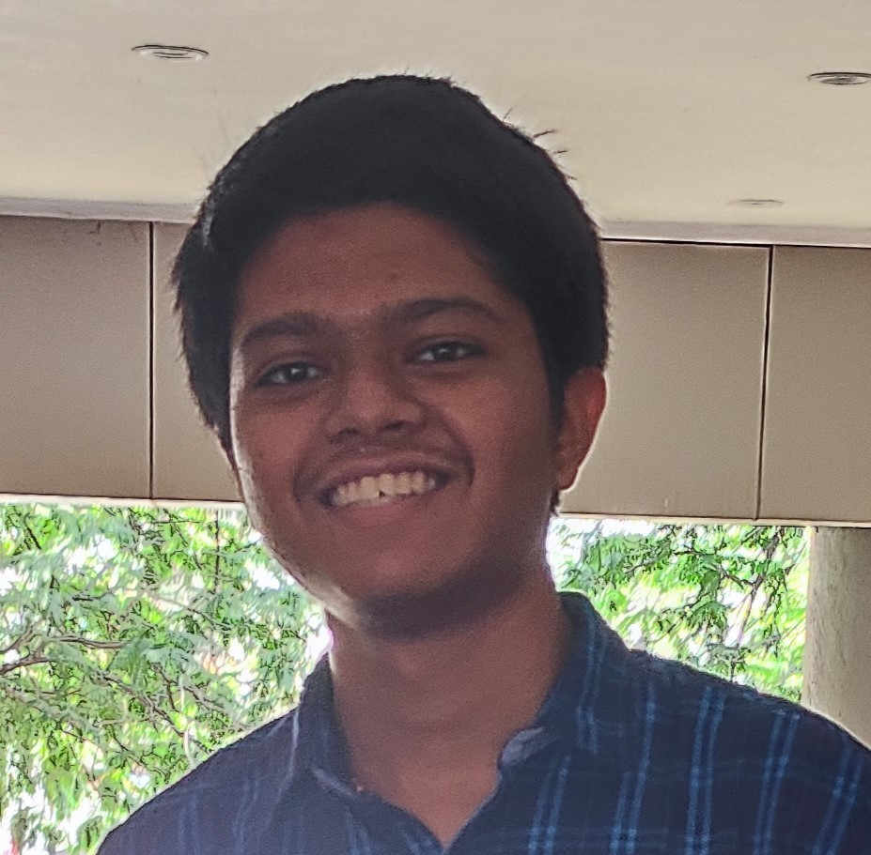
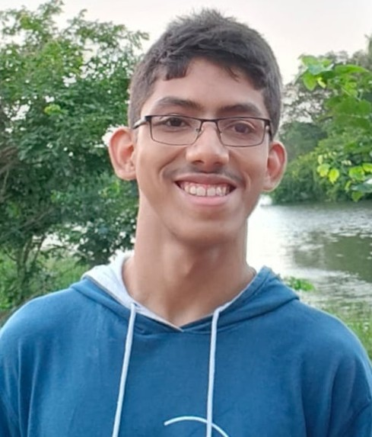 | Adwait Purao, B.Tech Computer Engineering Depart- ment, Sardar Patel Institute of Technology. Adwait Purao is a Computer En- gineering student at Sardar Pa- tel Institute of Technology with a strong background in web devel- opment, UI/UX design, and soft- ware engineering. He has demon- strated technical expertise through projects, an Oracle internship, and leadership in Google Developer Students Club and Students’ Developer Club, with proficiency in technologies like React, Node.js, and multiple programming languages.
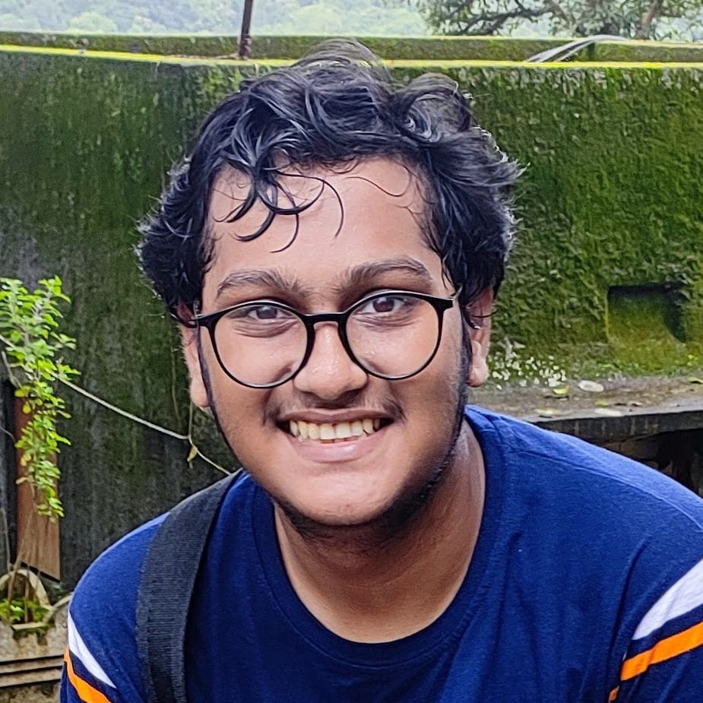 | Pranay Singhvi, B.Tech Computer Engineering Depart- ment, Sardar Patel Institute of Technology Pranay Singhvi is an undergrad- uate Computer Science student at Sardar Patel Institute of Tech- nology, skilled in data structures, algorithms, and artificial intel- ligence. He has developed AI- driven healthcare solutions, realtime object detection systems, and data visualization dash- boards. Proficient in Python, machine learning, full-stack development, and frameworks like Dash, Flask, and React, Pranay has led projects such as SecureView, a real-time in- truder detection system in Hackathon. He also has experience with databases like MySQL.
Tathagat Sengupta, B.Tech Computer Engineering Depart- ment, Sardar Patel Institute of Technology.
Tathagat Sengupta is an aspiring Computer Science professional pursuing his degree at Sardar Pa- tel Institute of Technology. With a strong foundation in Python, machine learning, and full-stack development, he has contributed to impactful projects, including AI-driven healthcare appli- cations, real-time object detection systems, and interactive data analytics dashboards. Tathagat’s technical expertise spans across frameworks such as Flask, React, and Dash, alongside experience in machine learning algorithms, data visualization tools, and database management systems like MySQL and MongoDB. His projects demonstrate his ability to apply cutting-edge technologies to solve real-world challenges.

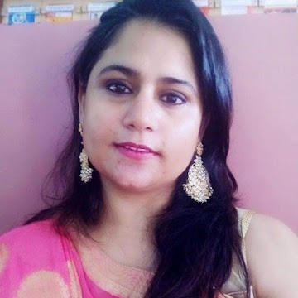 | Dr. Renuka Pawar  Dr. Renuka Pawar, IEEE member and an Assistant professor in the Computer Science and Engineer- ing department of Sardar Patel Institute of Technology, Mumbai. Working in the field of security in wireless sensor networks and hav- ing over 15+ Years of experience in teaching & research. Areas of interest include Linux operating systems, system and web security, network security,and WBAN security. Conducted various sessions on OWAPS, Ethical hacking, and digital forensics at various places.Published 15+ research papers in various conferences,5+ research papers in journals, and one poster in the research colloquium. Have participated and presented a research proposal in the final round of the 15th intercollegiate/institute/department Avishkar research conven- tion 2020-21 organized by the university of Mumbai on July 1st, 2021. Received a gold Winner of the Innovation Challenge during 2024 IEEE R10 Humanitarian Technology Conference.

